2-3 Milestone One: Project Proposal
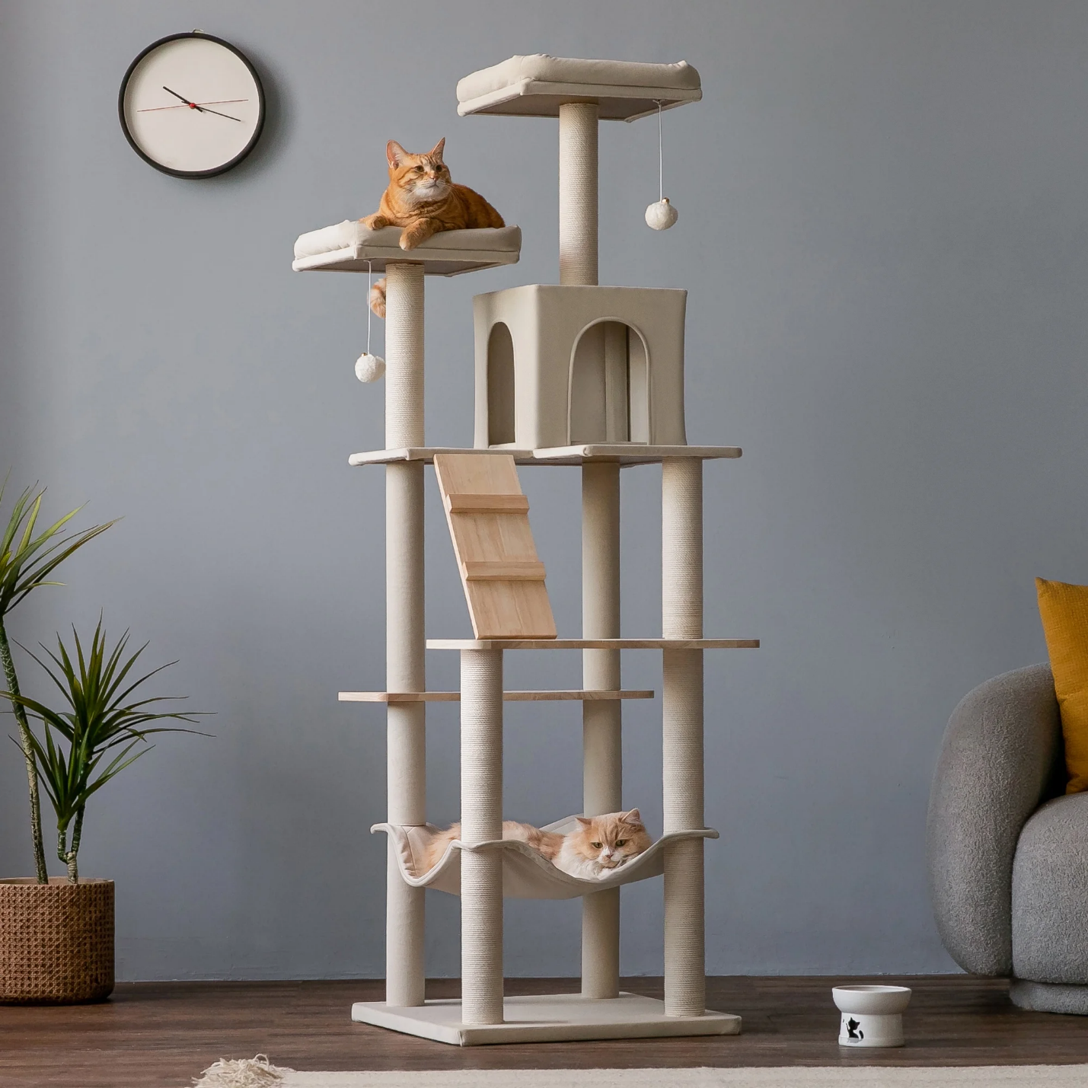
The 2D image I decided to replicate into a 3D scene is this image of a modern indoor cat tree. The image consists of various different shapes, the cat tree itself consists of multiple shapes that can be replicated into a 3D image.
After looking at this image, I decided to replicate the cat tree, the cat bowl, a cat, and the flooring. The different basic 3D shapes I would use a cylinder, box, sphere, plane, torus, and cone. The scratching posts will be replicated as cylinders since they are ideal for modeling tall, rounded columns and can be scaled easily to match the image proportions. The flat platforms on the cat tree will be replicated as boxes since they provide clean edges and flat surfaces, making them perfect for modeling rectangular platforms. The cubby enclosure will be replicated by a combination of a box and cylinder to represent its hollow interior. The hanging toy ball will be replicated by a combination of a sphere and cylinder since the string is long and narrow and the sphere captures the smooth, curved shape of the toy and adds visual contrast to the angular platforms. The cat will be replicated by combination of spheres and cones by using a sphere to create the head, a stretched sphere to create the body, and the cones as the ears as it captures the essential silhouette of a cat while keeping the geometry simple and achievable within the project scope. The cat bowl will be replicated by a combination of a torus and cylinder as the cylinder forms the main body of the bowl, which provides the flat base and vertical sides and the torus is placed around the top edge to create the rounded lip characteristics. The ground floor will be represented by a plane to ground the scene and provide spatial context.
Overall, these items offer a range of shapes and modeling challenges by combining simple geometric forms into more complex structures. The selected objects are visually interesting, structurally achievable, and provide a clear path for practicing shape creation, positioning, and composition in OpenGL. This scene is engaging because it combines organic and geometric forms, allowing me to practice both structural modeling and simple character modeling.

